Experiment-2
Student Name:Raj Kumar Singh UID: 23BCS11393
Branch: CSE Section/Group: KRG-3B
Semester: 6th Date of Performance: 14/01/26
Subject Name: System Design Subject Code: 23CSH-314

- AIM : To design an online E-commerce platform similar to Amazon/Flipkart for browsing and purchasing products like mobiles, laptops, cameras, and clothes.
To implement Kafka, Elasticsearch, and a CDC pipeline for real-time data processing, fast search, and scalability.

- Objective:
- To develop a scalable online shopping system for product listing, search, and order management.
- To use Apache Kafka for real-time event streaming and inter-service communication.
- To implement Elasticsearch for fast and efficient product search.
- To integrate a CDC pipeline for real-time synchronization between databases and services.

- Tools Required:
- Programming Language: Java / Python / JavaScript
- Backend Framework: Spring Boot / Express.js / Flask
- Database: MySQL / PostgreSQL / MongoDB
- API Testing Tool: Postman
- Design Tool: Draw.io (for HLD diagrams)
- Web Browser
- ElasticSearch
- Kafka
- CDC connector
- SYSTEM DESIGN / SYSTEM SPECIFICATION:
  - Functional Requirements:
- User should be able to search and find the products based on product title or names.
- User should be able to view the details of the product llike description, image, available quantity, review, accessed.
- User should be able to select the quantity and move the product/item into the cart.
- User should be able to make the payment and should be able to perform the check out.
- User shoulde be able to check the status of the order.
- System should be able to manage purchase of items having limited stocks.

  - Non-functional Requirements:
- Target Scale: 100Million DAU with 10 orders processed per second.Availability – System should be available 24/7
- Consistency & Availability: Here for this system we need both as per the Target Scale.
Now we should specifiy that, which part of our system needs what?
- Latency: Required: ~200 ms
- Scaling: Horizontal / VerticalConsistency

  - Core-Entites of the System:

  - User / Client
  - Product
  - Cart
  - Orders
  - Checkout followed by Payment

  - API Endpoints Creation:
1. GET API Call: Prod_Search
Https://Local_Host/products/search_item = {Search_keywords}
HTTP Req
{
GET: <iPhone 16>
}
HTTP Res
{
<ProductID:iPhone>
}
Now, on front-end if multiple data of respective product is coming in that case the FE becomes faulty -> ultimately increasing the LATENCY.
For that: we can use Pagination 1, 2 ,3 ,4 ,----- SO ON

2. GET API Call: View Product Details
Https://Local_Host/products/{product_id}
HTTP Req
{
GET: <Product_id = 17>
}

HTTP Res
{
Product_id:17,
Name: iPhone 17,
Color: Navy Blue,
Price: $1099,
Image Thumbnail: URL_Image
}

3.POST API Call: Item add in cart
Https://Local_Host/cart/add_products

HTTP Req
{
Product_id = 17,
Product_id = 16
}

HTTP Req Header
{
User_id: 04
}

HTTP Res
{
Cart_id: 101
}
4. PUT API Call: To update any order in the cart

Let's Suppose you want to add one more product into the cart.

5.DELETE API Call: To remove any item from the cart

Let's Suppose you want to delete one more product into the cart.

6.POST API Call: for check out & Payement
Https://Local_Host/checkout -> {post body}
HTTP REQ
{
All products ID's,
Total Quantity,
Total Price
}
HTTP RES
{
Order_ID
}

Https://Local_Host/payment -> {post body}
HTTP REQ
{
Order ID,
Payment Type,
Payment Mode
}
HTTP RES
{
Confirmation_Status: Succes / Fail
}

7.GET API Call: Order Status

Https://Local_Host/orde_status = {order_id}

- HLD(High Level Design):

We have to follow a distributed / micro-services approach not the monolithic one.
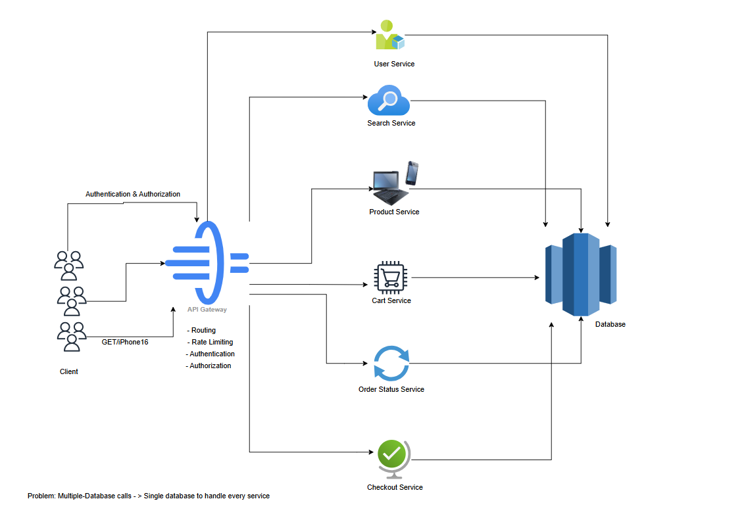


DEPARTMENT OF
COMPUTER SCIENCE & ENGINEERING

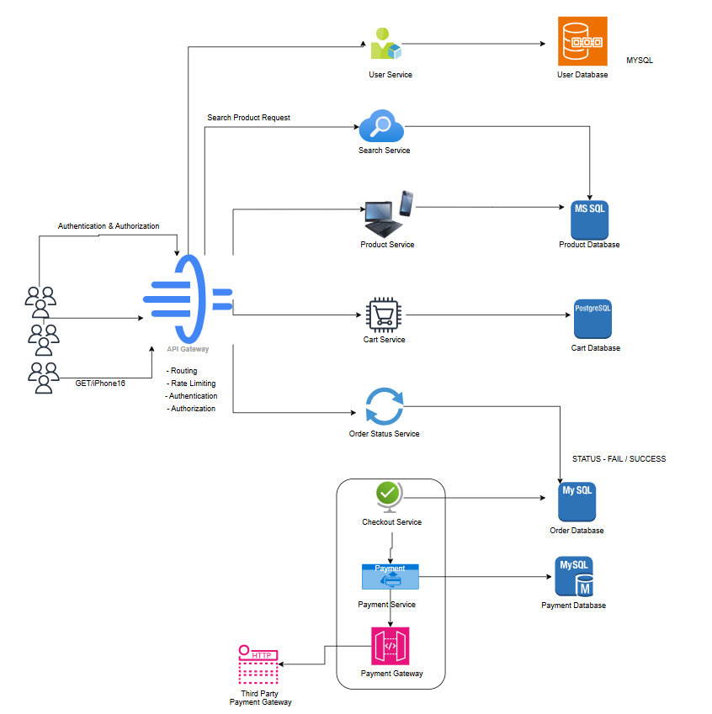

- LLD(Low Level Design
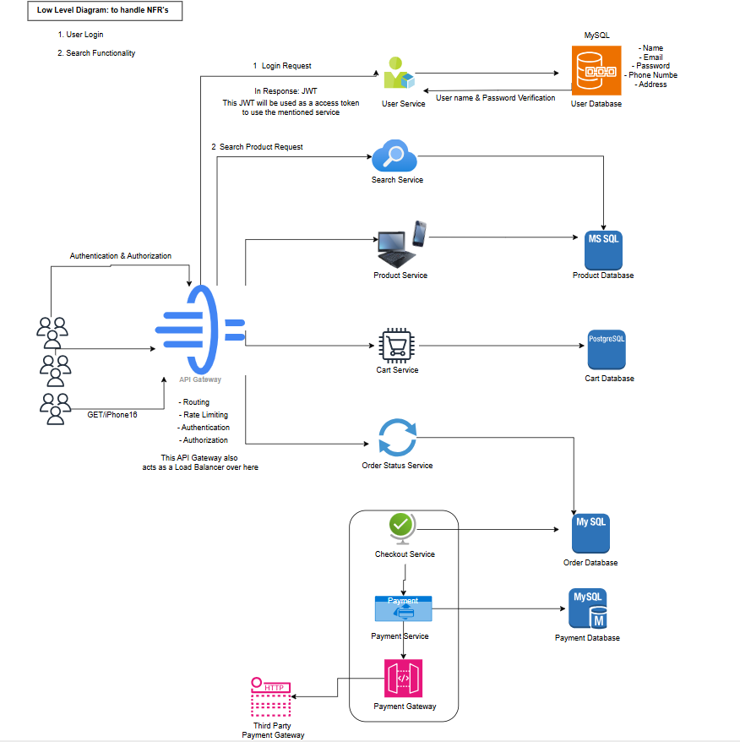

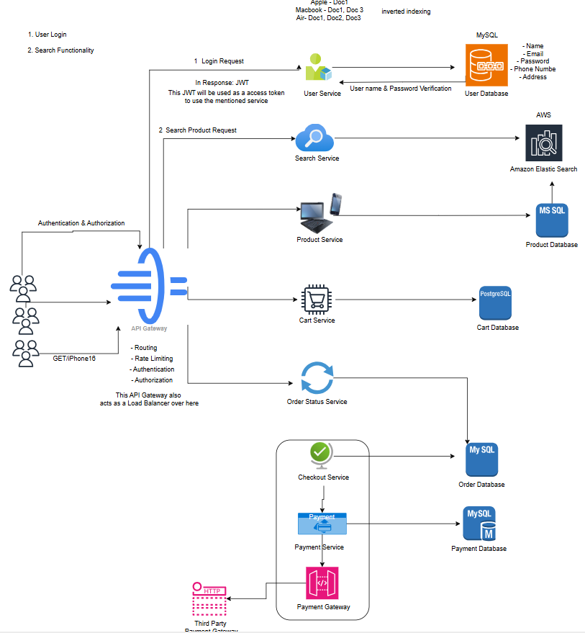

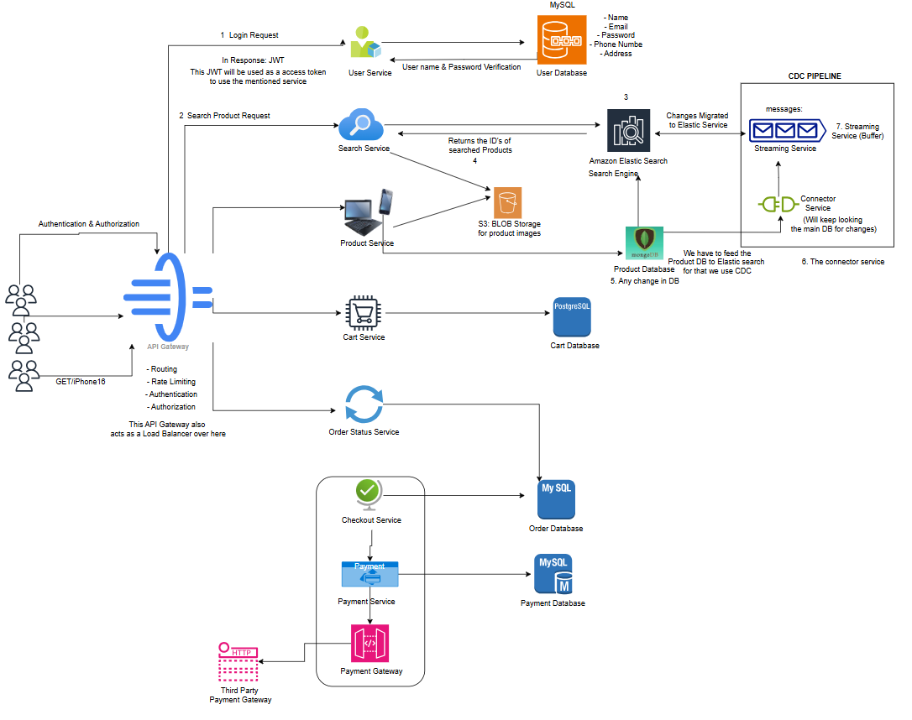
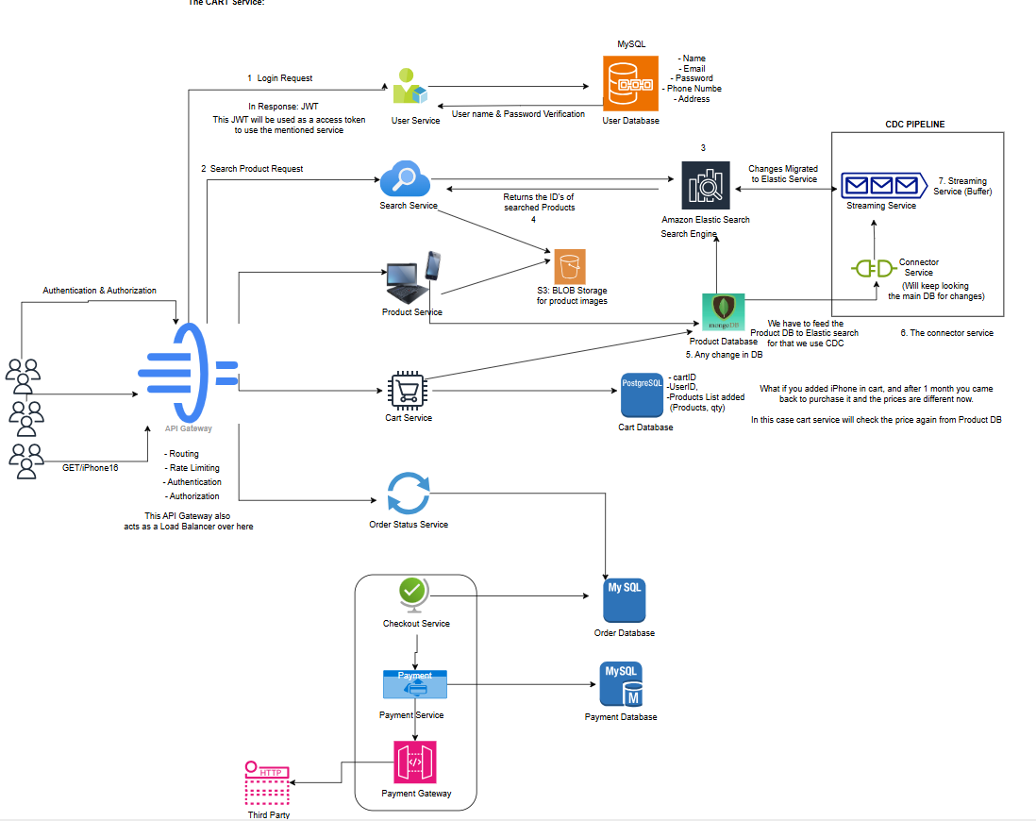
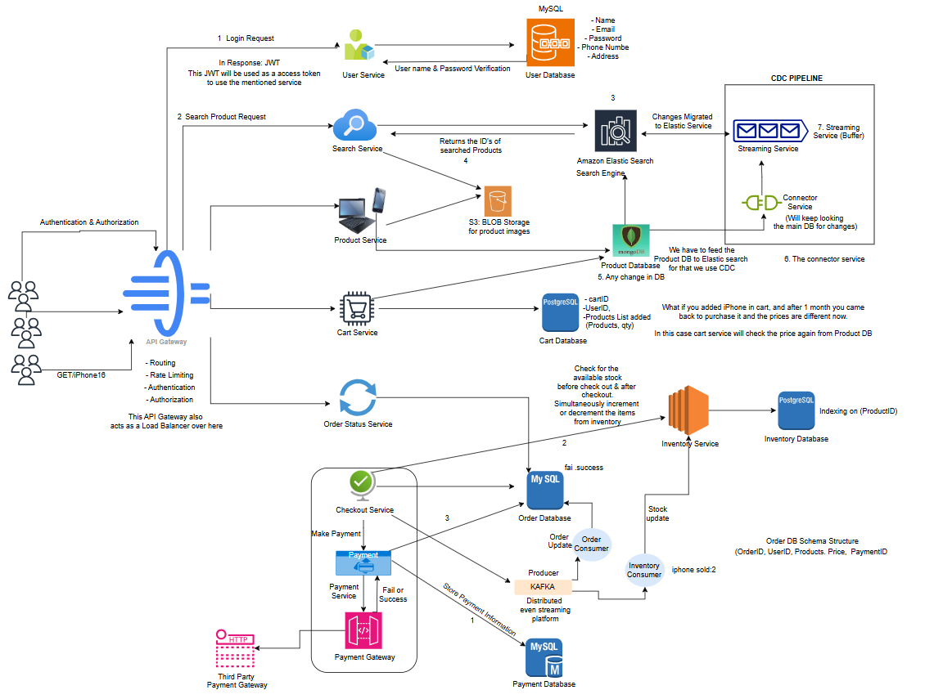

- Learning Outcomes
• Understand the design and architecture of a scalable E-commerce platform.
• Gain hands-on experience with Apache Kafka for real-time data streaming.
• Learn to implement fast and efficient search using Elasticsearch.
• Understand Change Data Capture (CDC) pipelines for real-time data synchronization.
• Develop skills in integrating distributed systems for high availability and scalability.

